Checkmate user guide

Alvin Charles

Contents

Installation 2

Extraction 2

Execution 3

Usage 4

Introduction 4

Starting new game 4

Starting a new timed game 6

Playing the game 7

Moving pieces 7

Taking back moves 8

Saving games 8

Loading games 9

Options 10

Navigating to the options screen 10

Setting the timer refresh interval 12

Enable or disable switching board sides after moves 12

Setting the length of delay between moving and switching board sides 12

Customising colour scheme 12

Saving, restoring or cancelling changed options 12

Viewing high scores 13

Other 13

Menus 13

About screen 13

Resignation 14

Troubleshooting 14

Game not starting 14

Invalid Checkmate file error shows up when trying to load saved game 14

# Installation

To install Checkmate, you must first extract it.

## Extraction

First locate your compressed Checkmate zip file in File Explorer. See *Figure 1*.

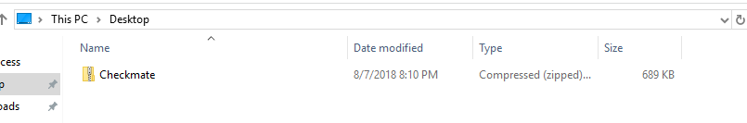

Figure 1 – Locating your compressed Checkmate zip file

Then, right click on the file to open the context menu and select ‘Extract All…’.

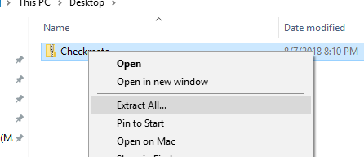

Figure 2 - Selecting the 'Extract All...' option

A window will then show allowing you to choose the extraction location. This location can be anywhere. By default, it will be where the zip file currently is.

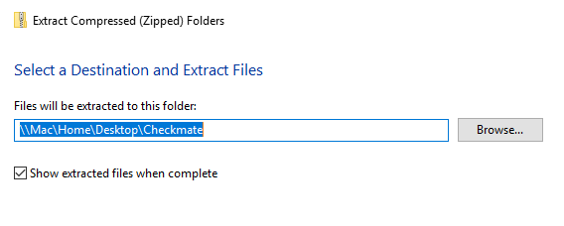

Figure 3 - Choosing extraction location

A screenshot of a cell phone

Description generated with very high confidence

Figure 4 - The extraction taking place

Afterwards, locate the extracted files. You have now extracted the necessary files to run Checkmate.

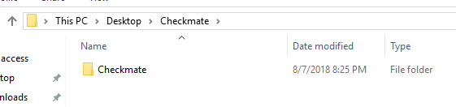

Figure 5 - The extracted files

## Execution

To execute Checkmate, navigate to the game folder (see *Figure 5*) and double click to see the files inside. There will be two items – a folder named resources and an executable named Checkmate.

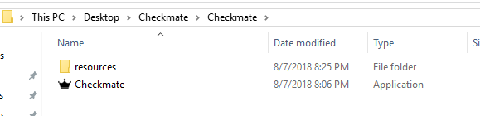

Figure 6 - The game files

Double click ‘Checkmate’ to run the file.

# Usage

## Introduction

Checkmate is a chess playing app that supports all FIDE international rules of chess, apart from the three-move repetition draw claim and fifty-move rule. It supports every playing style and type of player through its heavy customisability in almost every aspect.

A sample of its features include:

* Customisable color schemes and game options
* Saving and loading games
* Keeping high scores of the shortest times to win a game
* Taking back moves
* Customisable timed games

In this user manual, you will find all the advice you need to use Checkmate well.

## Starting new game

To start a new game, first launch the Checkmate app (see *Figure 7.*)

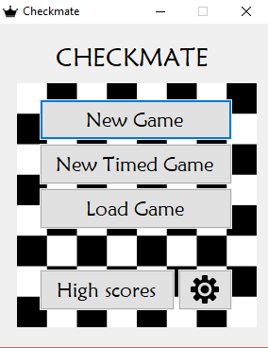

Figure - Checkmate main menu screen

Then click the New Game button (see *Figure 8*.) After entering your names, press confirm.

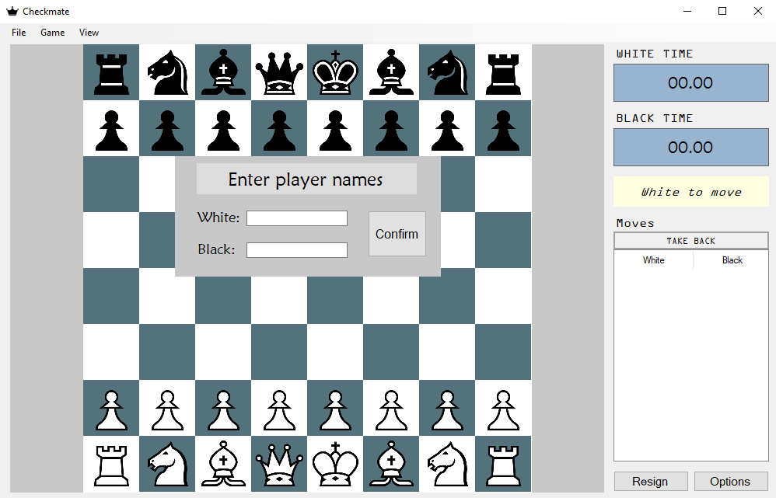

Figure - Checkmate after 'New Game' is pressed from the main menu

One more dialogue should appear. After confirming this, the timers will start to function, and the game commences.

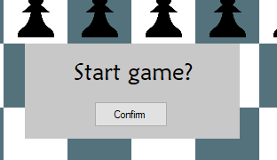

Figure - The final dialogue before a new game is started

### Starting a new timed game

To start a new timed game, first launch Checkmate (see *Figure 7*) and then click ‘New Timed Game’ (see *Figure 10.*)

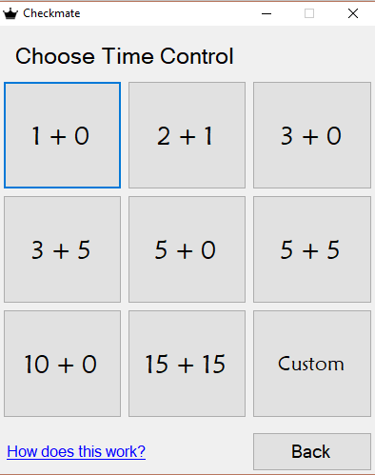

Figure - Screen shown after 'New Timed Game' is clicked

If you are unsure about how time controls work, click the blue ‘How does this work?’ link to get an overview on time controls. If the time control you want to play with is displayed on the grid of boxes, click that to get started. Afterwards, see *Figure 8* and *Figure 9* for the process to start the game and run the timers.

If however, you want to create your own time control, click the ‘Custom’ button (see *Figure 11*.)

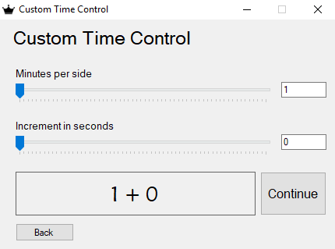

Figure - Custom time control screen

On this screen you can create your own time control. Either use the trackbars or the textboxes to change the minutes per side and increment values. A preview of your time control is shown left of the ‘Continue’ button. When you are done creating your time control, click ‘Continue’ to launch to the *Figure 8* and *Figure 9* screens.

## Playing the game

### Moving pieces

To play the game, first click on a piece you want to move (see *Figure 12*.)

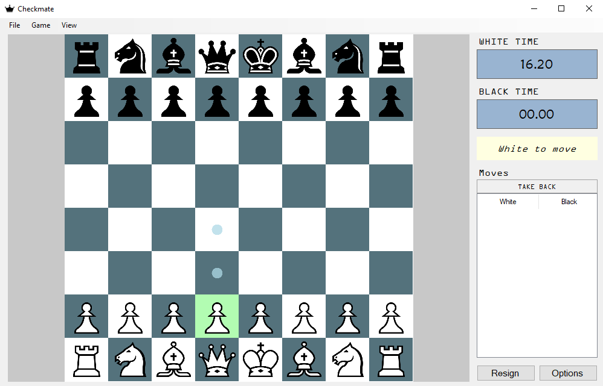

Figure - Selecting a piece to move

All the valid moves for that piece will show on the board. To then move the piece to any of the indicated positions, click on them. In the event of a pawn promotion, the dialogue shown in the screen in *Figure 13* will show. Select a piece and click it for the pawn to change to it and continue the move.

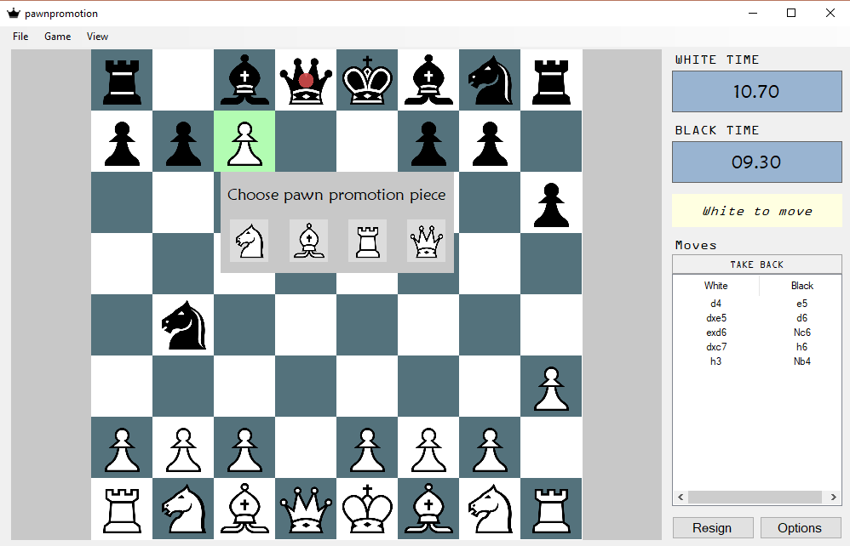

Figure - Choosing a piece for a pawn promotion

### Taking back moves

To take back a move, click on the ‘TAKE BACK’ button above the game history. This will take the game one move back.

## Saving games

To save the game, either press the keyboard shortcut ‘CTRL-S’ or navigate the file menu to the ‘Save…’ options as shown in in *Figure 14*.

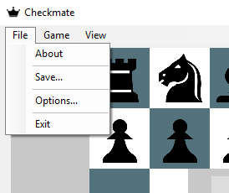

Figure - Saving a game through the file menu

Then a save game dialogue will show, as seen in *Figure 15*.

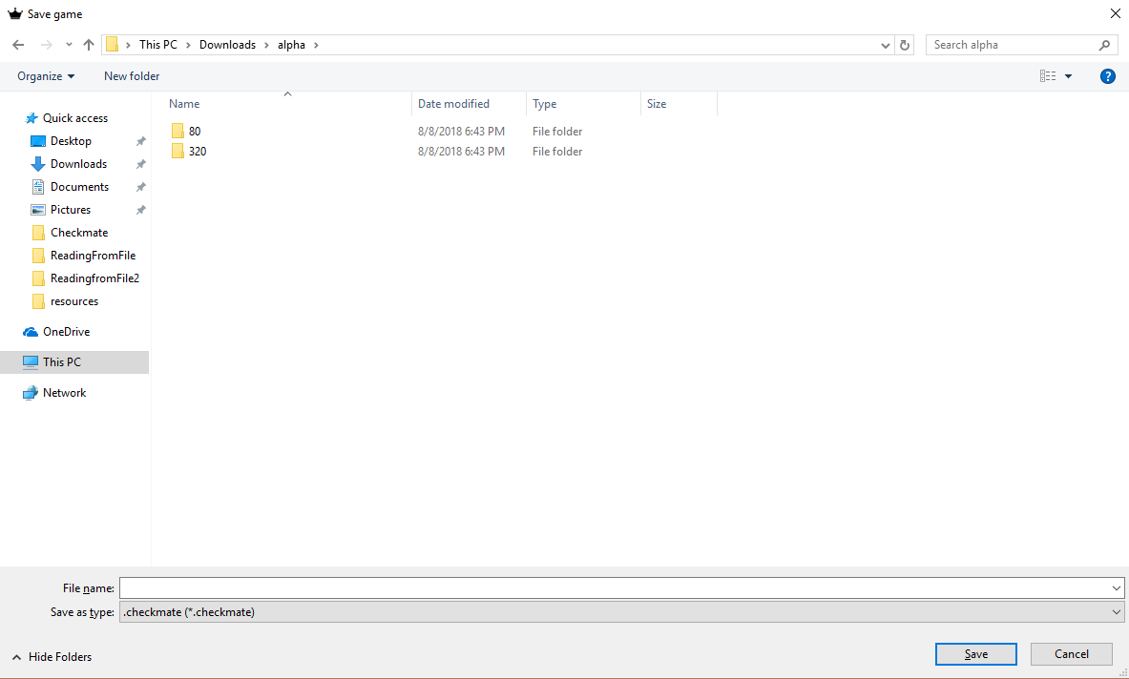

Figure - Saving a game

After choosing a location and a name for your game, a Checkmate file will be created containing all the game data.

## Loading games

To load a previously saved game, first open Checkmate and click the ‘Load Game’ button (see *Figure 7*.)

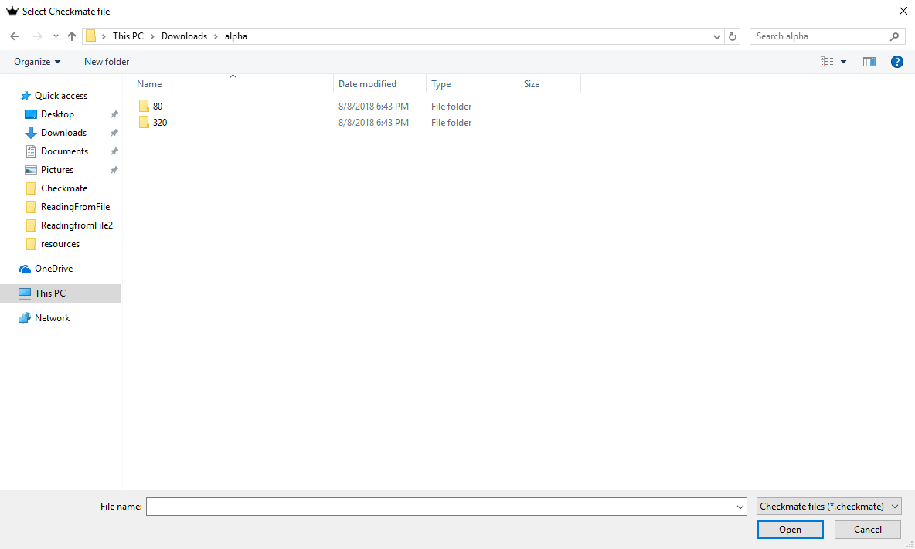

Figure - Load game file dialogue

Then navigate to your saved Checkmate file and open it to continue.

## Options

Checkmate has many customisable options, mainly located in the options screen. This section will explain the various options there are and how to customise them.

### Navigating to the options screen

There are many ways to navigate to the options screen. The first is from the settings cog in the main menu, as seen in *Figure 17*.

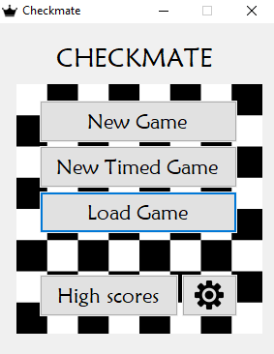

Figure - An edited screenshot showing how to access the options page from the main menu

The options screen can also be accessed from the File, Game and View menus inside a game as shown in *Figure 18*.

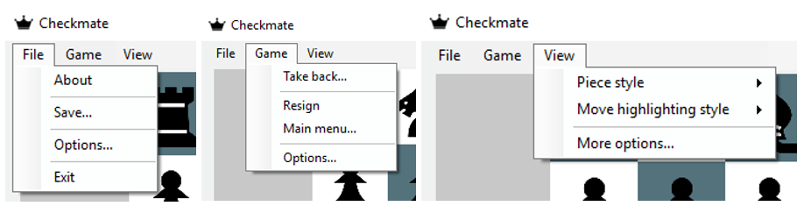

Figure - Accessing the options page from the File, Game and View menus

Once the options page is up, it should appear like in

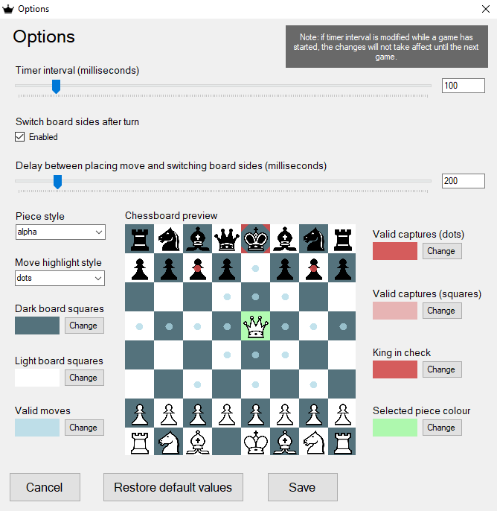

Figure - The options screen

As any setting is changed that changes the appearance of the chessboard, the chessboard preview gets updated to reflect the chosen settings.

Settings are also saved externally, meaning that your changes persist, even when you reboot Checkmate.

### Setting the timer refresh interval

To set the timer refresh interval, simply either move the ‘Timer interval (milliseconds)’ trackbar or edit the textbox to its right (see *Figure 19*.)

### Enable or disable switching board sides after moves

To enable or disable switching sides after a move during games, check or uncheck the ‘Switch board after turn’ checkbox (see *Figure 19*.)

### Setting the length of delay between moving and switching board sides

This option will be disabled if switching board sides is disabled. To change the length of delay between the time a piece is placed and the board rotates, either move the ‘Delay between placing move and switching board sides (milliseconds)’ trackbar or edit the textbox to the right (see *Figure 19*.)

### Customising colour scheme

To customise the colour scheme of the game, click any of the ‘Change’ (see *Figure 19*) buttons next to the colour previews to open a color picker (see *Figure 20*.)

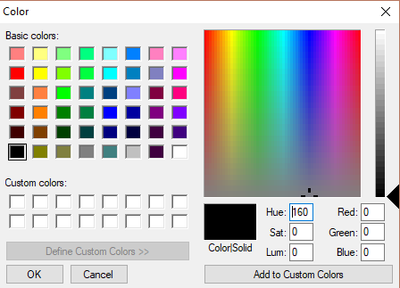

Figure - Colour picker for customising any game colours

### Saving, restoring or cancelling changed options

To cancel any changes you have made, select the ‘Cancel’ button (see *Figure 19.*) This will revert to the settings that were previously active and close the form.

To restore the default game values, select the ‘Restore default values’ button (see *Figure 19.*) This will restore the default game options.

To save your changes, select the ‘Save’ button (see *Figure 19.*) This saves your options.

## Viewing high scores

As soon as a game ends by either checkmate or a win on time, this is results is saved and added to the high scores. To view the high scores, open Checkmate to the main menu and then click the ‘High scores’ button (see *Figure 7.*) A window should display showing a sorted list of the high scores, such as in *Figure 21*.

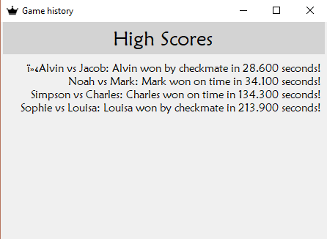

Figure - The high scores display

## Other

### Menus

There are more options in the menus, as can be seen in *Figure 18*. These options are all accessed by clicking on them through their respective menus.

### About screen

To view attribution and credits, go the ‘File > About’ menu.

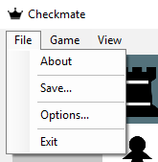

Figure - Accessing the about screen

This will open a window showing credits and attribution for resources used in the project (see *Figure 23*.)

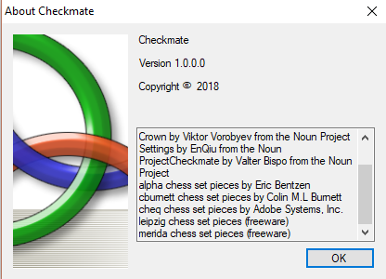

Figure - The about screen

### Resignation

There are two ways to resign. The first is through the ‘Resign’ button on the main chess screen (see *Figure 12*), or through the ‘Game’ file menu (see *Figure 24*.)

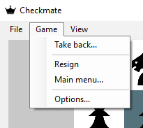

Figure - Resigning through the Game menu

# Troubleshooting

## Game not starting

If your game is not starting, check that you have extracted it before you try to run it. If you have already extracted it, check that there is a ‘resources’ folder wherever the Checkmate executable is. If there isn’t, unzip the Checkmate compressed file again and copy the resources folder to wherever you put the Checkmate executable.

## Invalid Checkmate file error shows up when trying to load saved game

This means that your Checkmate file is corrupted, and cannot be read. Unfortunately, this problem cannot be resolved.